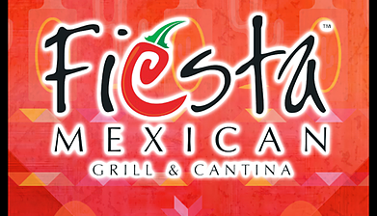

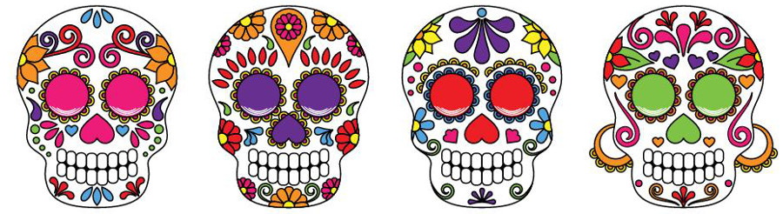
GO TO FIESTA, NOVEMBER 1 or 2,
Wednesday or Thursday
To CELEBRATE THE “DAY OF THE DEAD”
4-8PM
“Best Mexican restaurant in Oneonta!”
SUPPORT THE OHS SPANISH CLUB!
SEE SUGAR SKULLS AND THEIR STAFF DRESSED UP IN
“DAY OF THE DeAD” COSTUMES

Bring this coupon with you and give to your server
when you pay. Gracias!

